Assignment 1:

Creating Free Tier Account and Creating New IAM User whit S3 Permission

1. Created Account

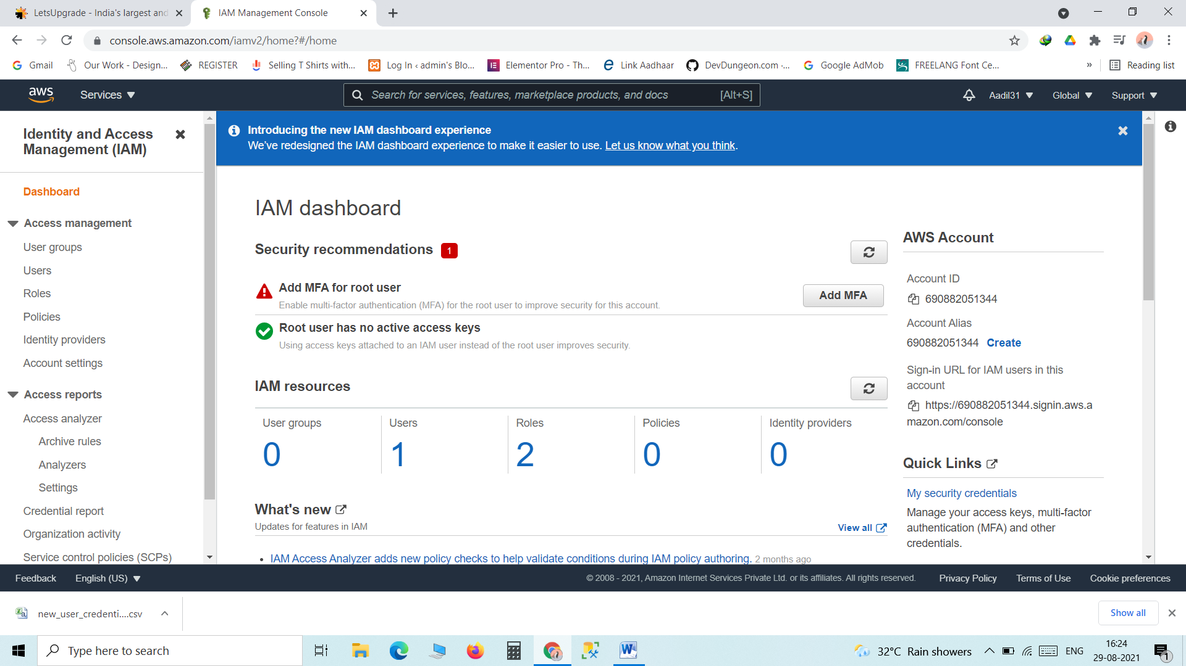

1. Created IAM User

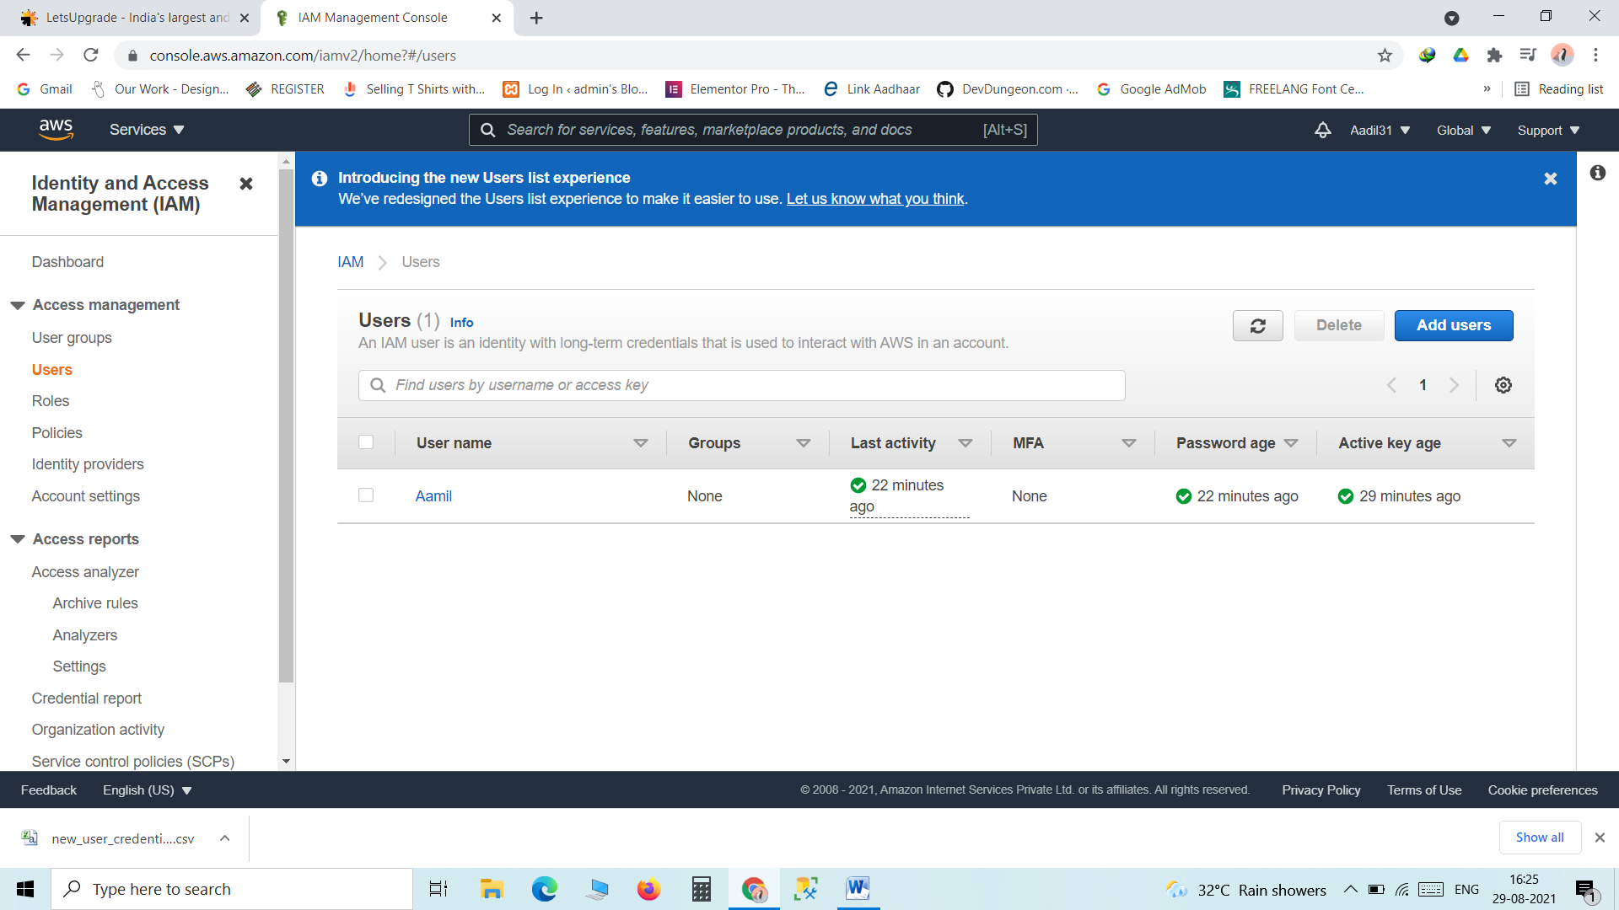

1. Given S3 Permission

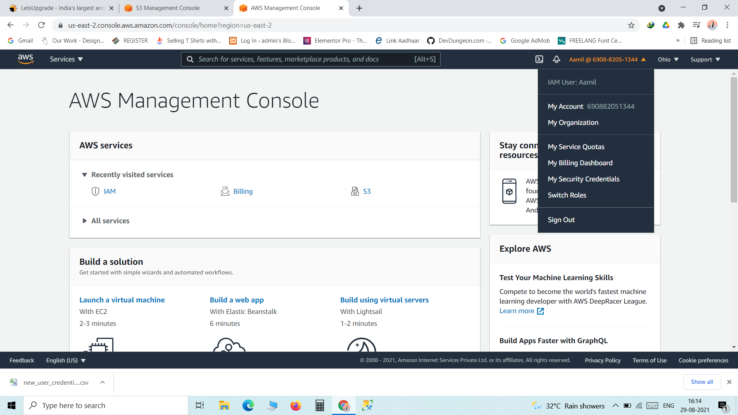

1. Accessing S3 operations

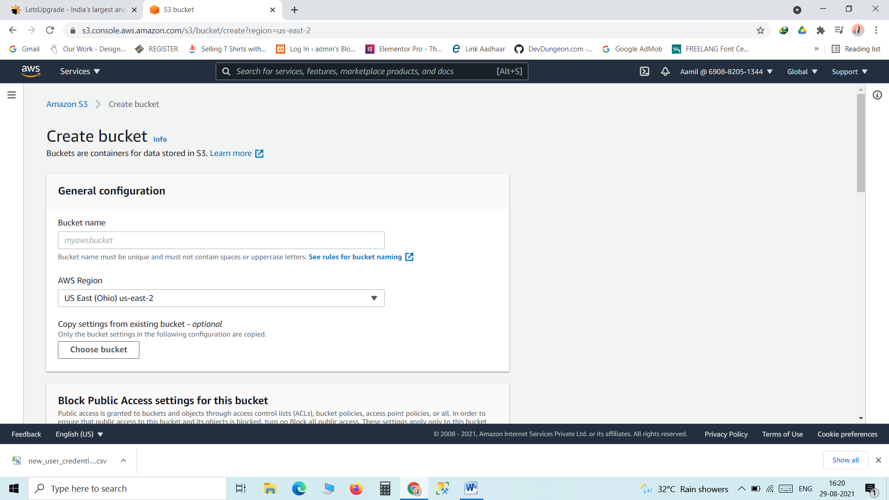

5.Unable to access other features

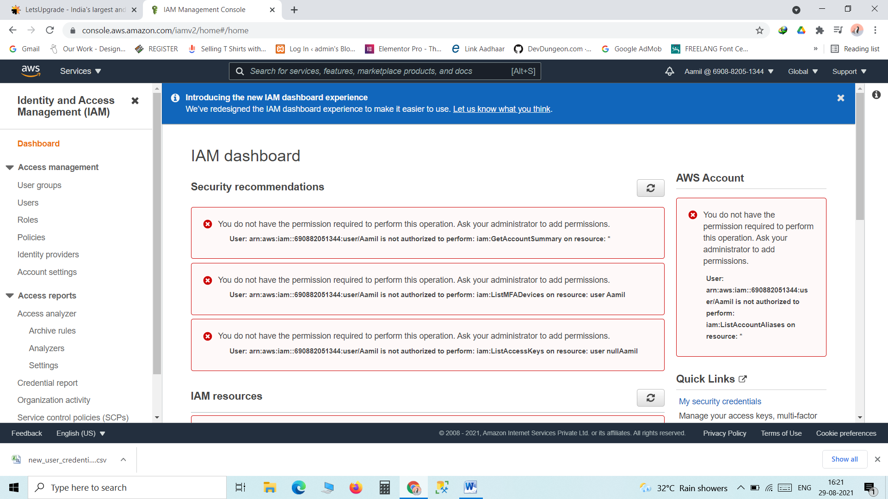

Submitted by:

Mohd Aadil Shafi

md.aadil.shafi@gmail.com